Directory Navigation
1. Display the current working directory using pwd.
2. List the contents of the current directory using ls.
3. Display hidden files using ls -la.
4. Navigate to the /tmp directory.
5. Return to your home directory using cd.
6. Navigate to /etc and display its contents.
7. Return to your home directory using a relative path and then using cd ~.
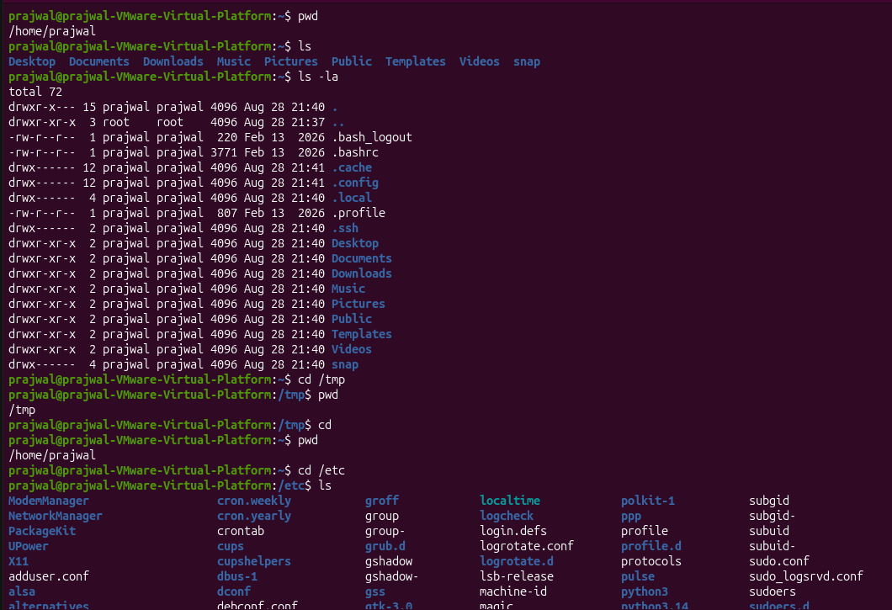
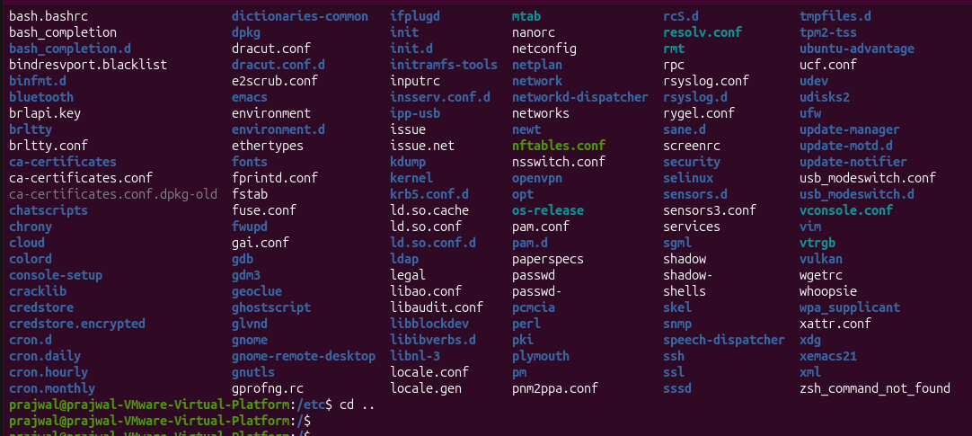
Creating Files and Directories
8. Create a directory named Linux_Assignment.
9. Inside Linux_Assignment, create the following directories: Documents, Scripts, Backup, Logs.
10. Create three empty files inside Documents: file1.txt, file2.txt, file3.txt.
11. Create a file named system_info.txt inside Linux_Assignment.
12. Display the directory structure using an appropriate command.
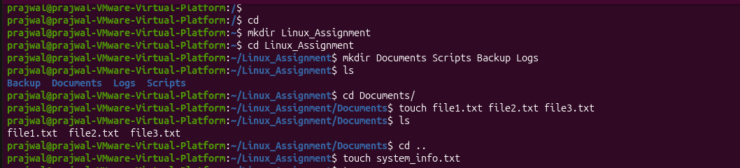
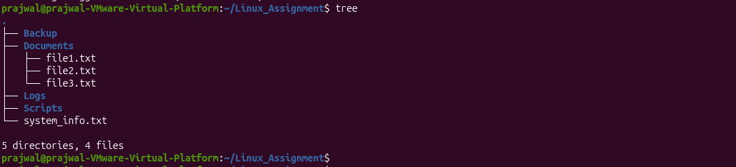

Working with Files
13. Add the following information to file1.txt: Name: <Your Name>; Course: <Your Course>;
Operating System: Linux.
14. Display the contents of file1.txt.
15. Copy file1.txt to the Backup directory.
Cd 16. Rename file2.txt to linux_commands.txt.
17. Move file3.txt from Documents to the Backup directory.
18. Create a new file named commands.txt and add at least 10 Linux commands to it.
19. Display the contents of commands.txt using cat.
20. Display the same file one page at a time using less.
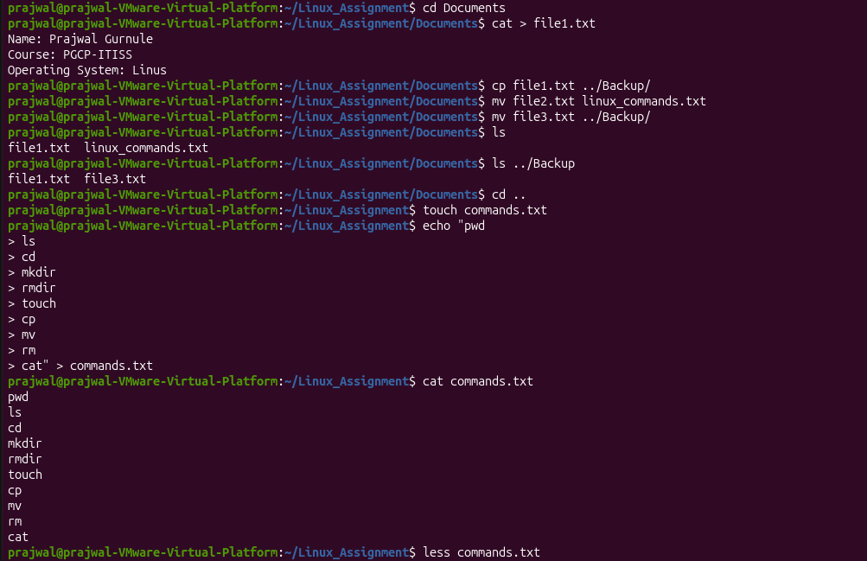
Viewing and Searching Files
21. Display the first 5 lines of /etc/asswd.
22. Display the last 5 lines of /etc/passwd.
23. Count the number of lines, words, and characters in commands.txt.
24. Search for the word Linux in file1.txt.

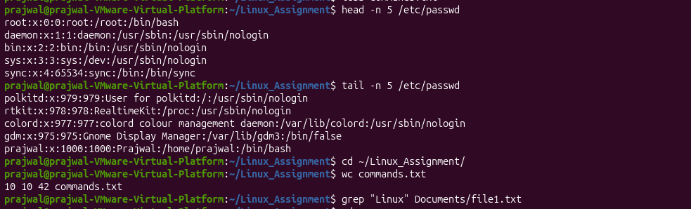

Introduction & File Navigation
Task:
- Create a directory ~/linux_lab and navigate into it.
- Create files file1.txt (content: "Hello World") and file2.txt (content: "Linux Basics").
- Use ls to list all files, then use ls
- Commands Tested: mkdir, cd, touch, echo, ls, ls
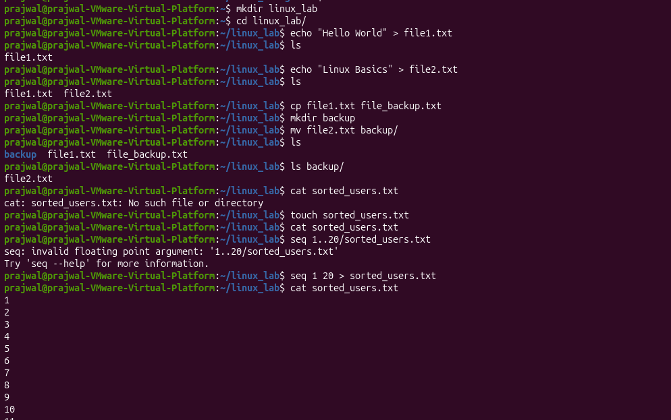

File Operations (Copy/Move)
Task:
- Copy file1.txt to a new file file1_backup.txt.
- Move file2.txt to a subdirectory backup/ (create it first).
- Verify all files exist using ls.
- Commands Tested: cp, mv, mkdir, ls
File Content Viewing (cat, tac, more)
Task:
- Display the content of sorted_users.txt using cat.
- Show the same file in reverse order using tac.
- Use more to view file1_backup.txt one page at a time.
- Commands Tested: cat, tac, more
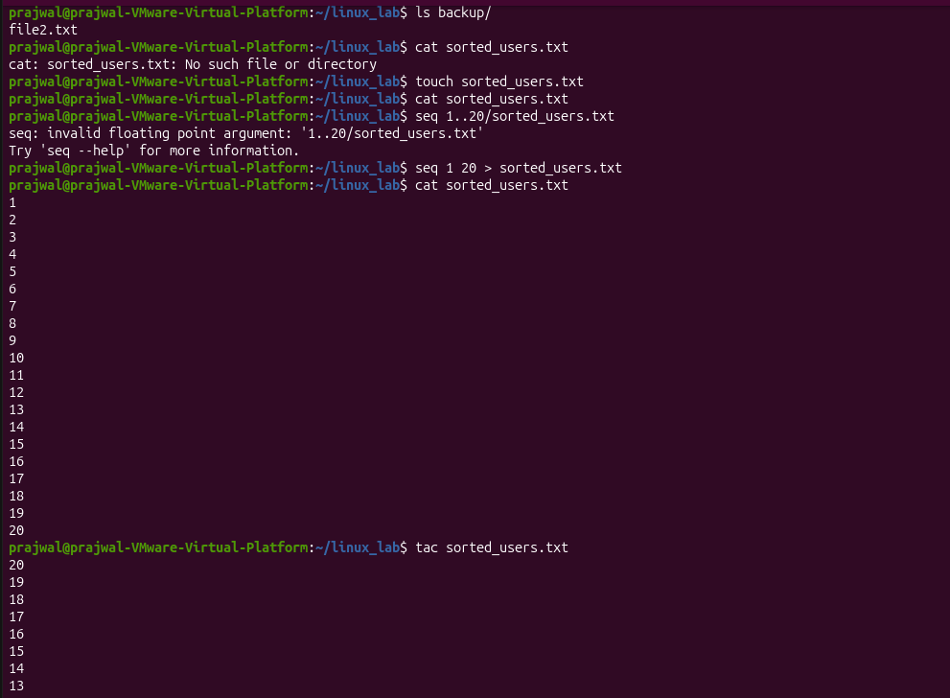
Extracting File Sections (head, tail)
Task:
- Show the first 2 lines of sorted_users.txt using head.
- Show the last 3 lines of sorted_users.txt using tail.
- Monitor the last 5 lines of a file system.log (create it with echo "log entry" > system.log).
- Commands Tested: head, tail, echo

File Creation & Redirection
Task:
- Use echo and redirection (>) to create report.txt with content: "System Report".
- Append today’s date to report.txt using date >> report.txt.
- Display the final content using cat.
- Commands Tested: echo, >, >>, date, cat
